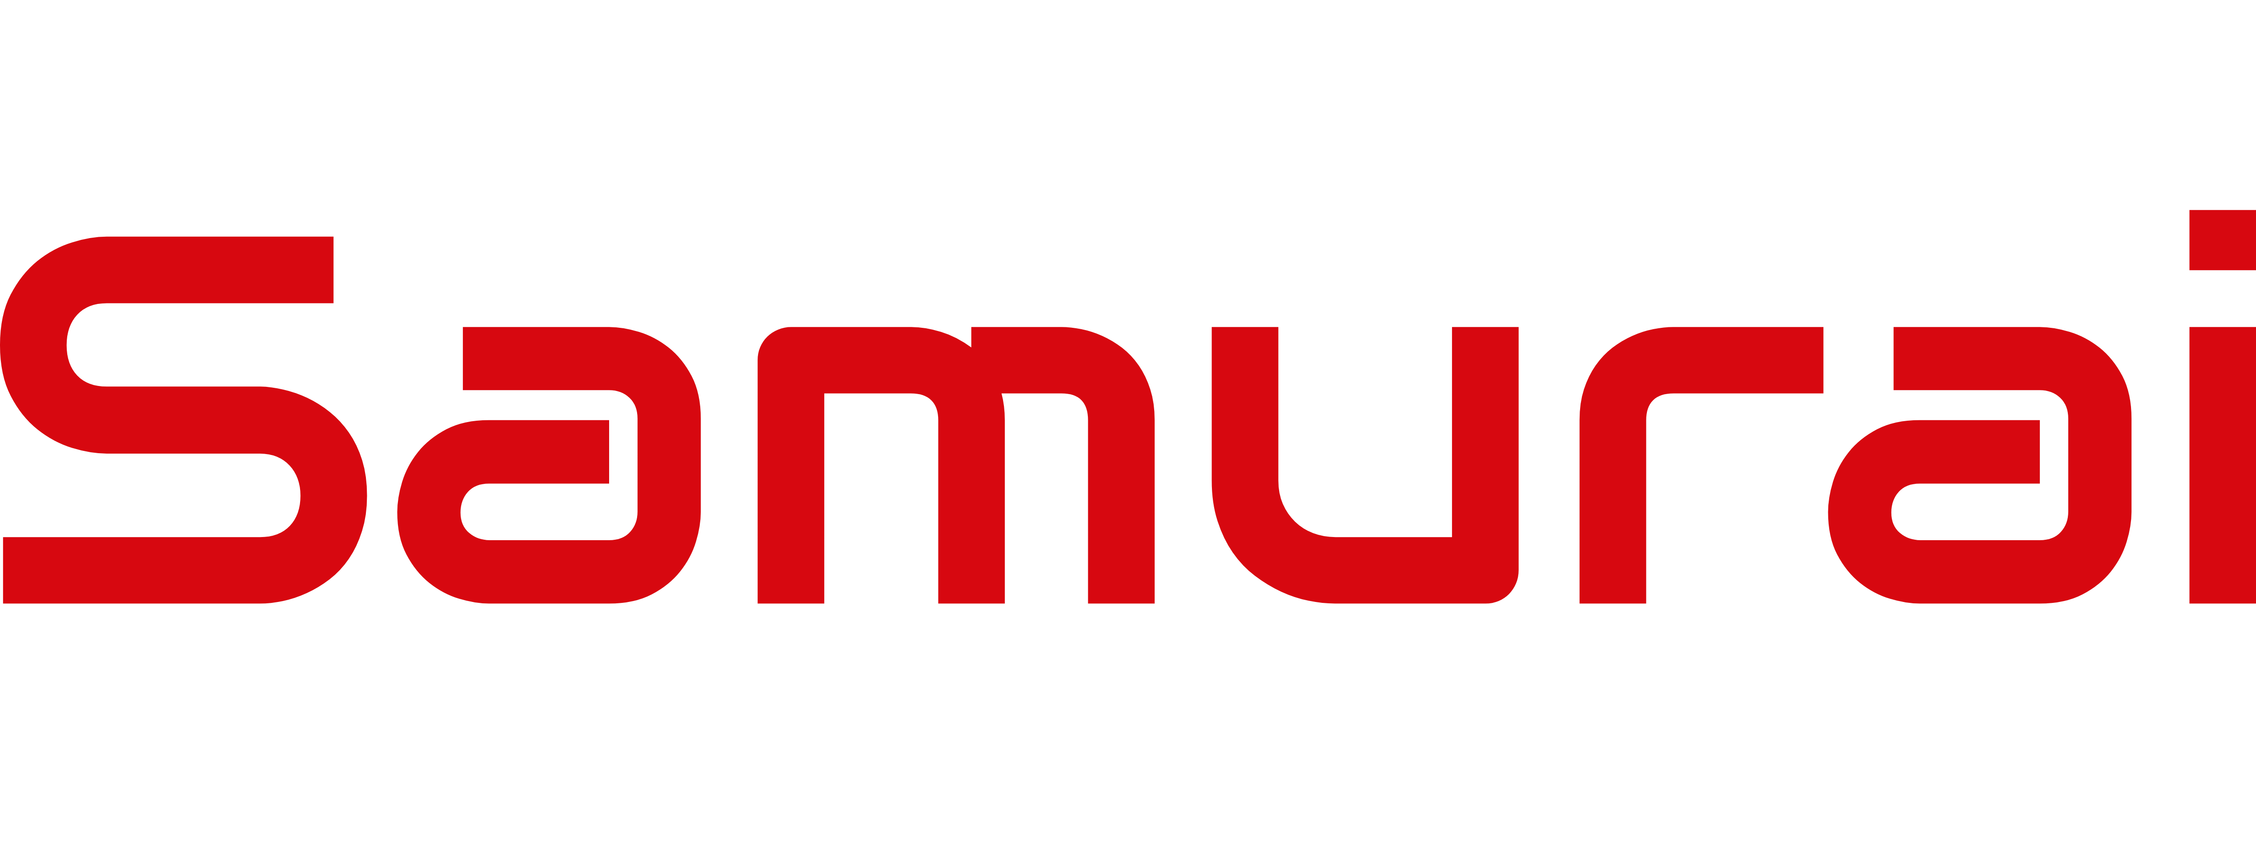
About RiskPulse
RiskPulse is not just another sentiment indicator. By combining Samurai's deep options experience with AI, this predictive intelligence tool rigorously examines equity and options trading to synthesize investor bias on a relative basis. RiskPulse sifts through billions of data points daily to present users with a quantifiable, fully objective view of the forward-looking 30-day risk of a given security having an outsized move beyond the mean to the upside (downside), relative to all other securities on the same date.

Why RiskPulse
The forward-looking nature, and relativity of RiskPulse are its key differentiators. Other sentiment indicators look at stale market data, historic correlations, momentum signals, social media, etc., to derive their findings. Many of them only examine sentiment on an absolute basis, reading stock X as either bullish or bearish. RiskPulse shifts this paradigm, empowering traders and risk analysts alike with an accurate, quantifiable account of future market expectations in a given stock, as it pertains to the relative sentiment of all other stocks.

About Samurai Data Analytics

Samurai is an innovative alternative data and intelligence solution for the capital markets. By leveraging AI and machine learning against alternative data sets, our unique solutions empower our clients to better define risks, identify opportunities, and most importantly, generate outsized returns.

Unlike most firms, we have developed our solutions from the ground up with traders and market participants in mind. With multiple latency options available, seamless integration and a highly scalable infrastructure, Samurai is flexible and easily deployable in any environment. Engineered by a sophisticated combination of proprietary methodology and niche industry expertise, our clients benefit from decreased volatility, lower market correlations and unmatched results.

- Market Timing
- Relative Strength
- Sentiment Analysis
- Predictive Intelligence
- Alpha Generation
- Risk Analytics
- Black Swan Detection
- Contrarian Indicator
- Trend Reversals
- Pairs Trading
RiskPulse is a proven and effective way for traders and risk managers to proactively protect against drawdowns, make better market timing decisions, and more efficiently deploy capital.
Key Takeaways
- Coverage on over 3,000 US stocks daily
- Predictive intelligence on relative market biases
- Uncovers new market-timing opportunities
- Provides key risk/hedging intelligence
- Contrarian Indicator & Black Swan Detector

RiskPulse Use Cases

RiskPulse
Forward-Looking Signal Gauging Relative Market Bias

www.samuraidata.com | sales@samuraidata.com | 877.437.9400

Copyright © Samurai Data Analytics LLC, 2020. All Rights Reserved.

